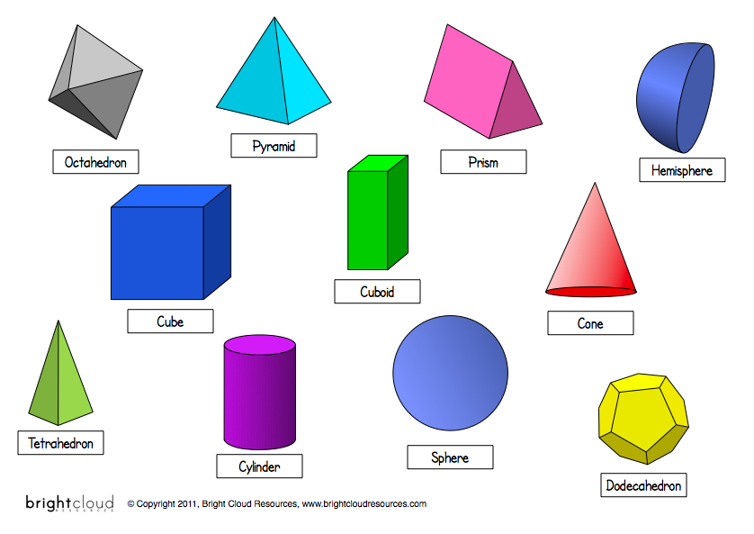

PreTest:

- How many faces does a cube have?
Draw a picture of the faces.
- How many faces does a cylinder have?
Draw a picture of the faces.

- How many faces does a tetrahedron have?
Draw a picture of the faces.

- How many faces does a pyramid have?
Draw a picture of the faces.

