Post Test

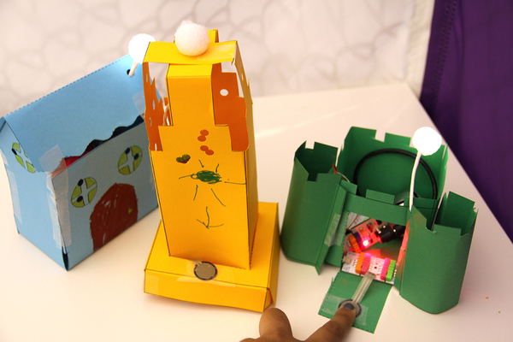

Draw the faces of your house in the space below.

