Drawing Bot Examples
Look at the designs below and consider the following questions:
- What littleBits modules power the bot?
- What other supplies are used?
- How does the robot autonomously draw art on paper?

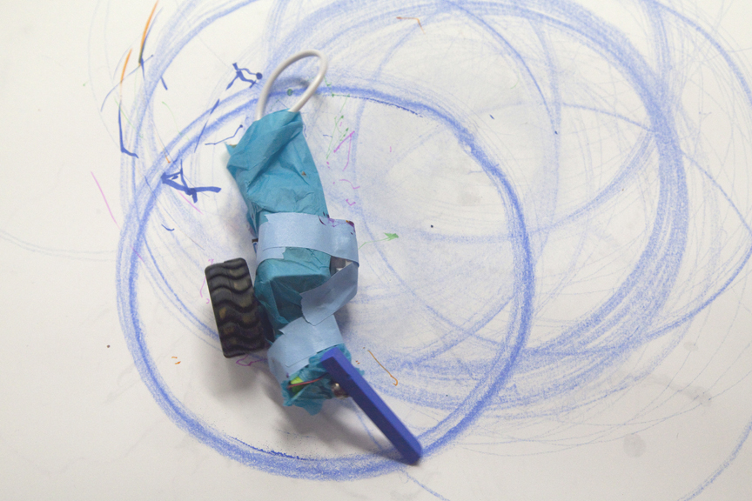
Spiral Robot (http://littlebits.cc/projects/spiralbot)

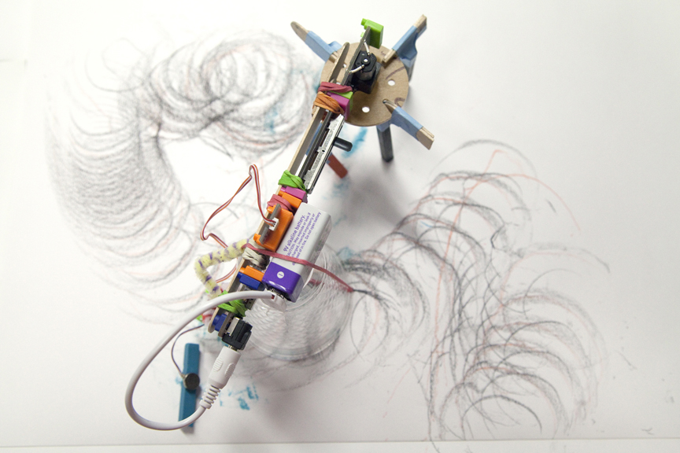
Unknown (http://littlebits.cc/projects/unknown)
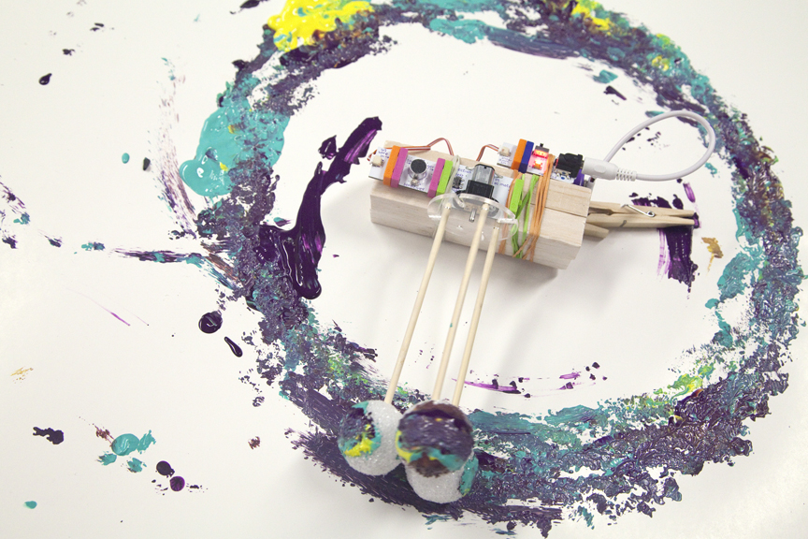
C. Robot (http://littlebits.cc/projects/c-robot)

